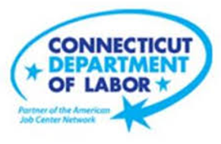

**NEW WEEKLY JOB POSTINGS FROM   
HELP WANTED ONLINE  
Office of Research**

**Week Ending December 24th, 2022: Health Care New Ads Fall to Typical Levels.**WETHERSFIELD, December 30th, 2022 – During the week ending December 24th, there were 6,186 new postings, down 655 or -10% over the week. This over-the-week drop is mostly due to shifts within Health Care & Social Assistance, which was down 679 new ads. Last week that industry was up 639 new ads. Most other industries had over the week change of +/-74 new ads. Among occupations, Registered Nurses (-287 new ads) had the largest over-the-week decline, which was over five times larger than the second largest decline, Marriage & Family Therapists (-57 new ads). Among the ten employers with the largest over-the-week declines, half were within Health Care & Social Assistance. The large one-week uptick in Health Care & Social Assistance during the week ending December 17th is larger than is typical for that industry. During the past 6 months, Health Care & Social Assistance new ads typically ranged between 1,000-1,900 per week. One year ago during the week ending December 25th, 2021, there were 5,695 total new ads and 1,313 in Health Care & Social Assistance.  
  
  
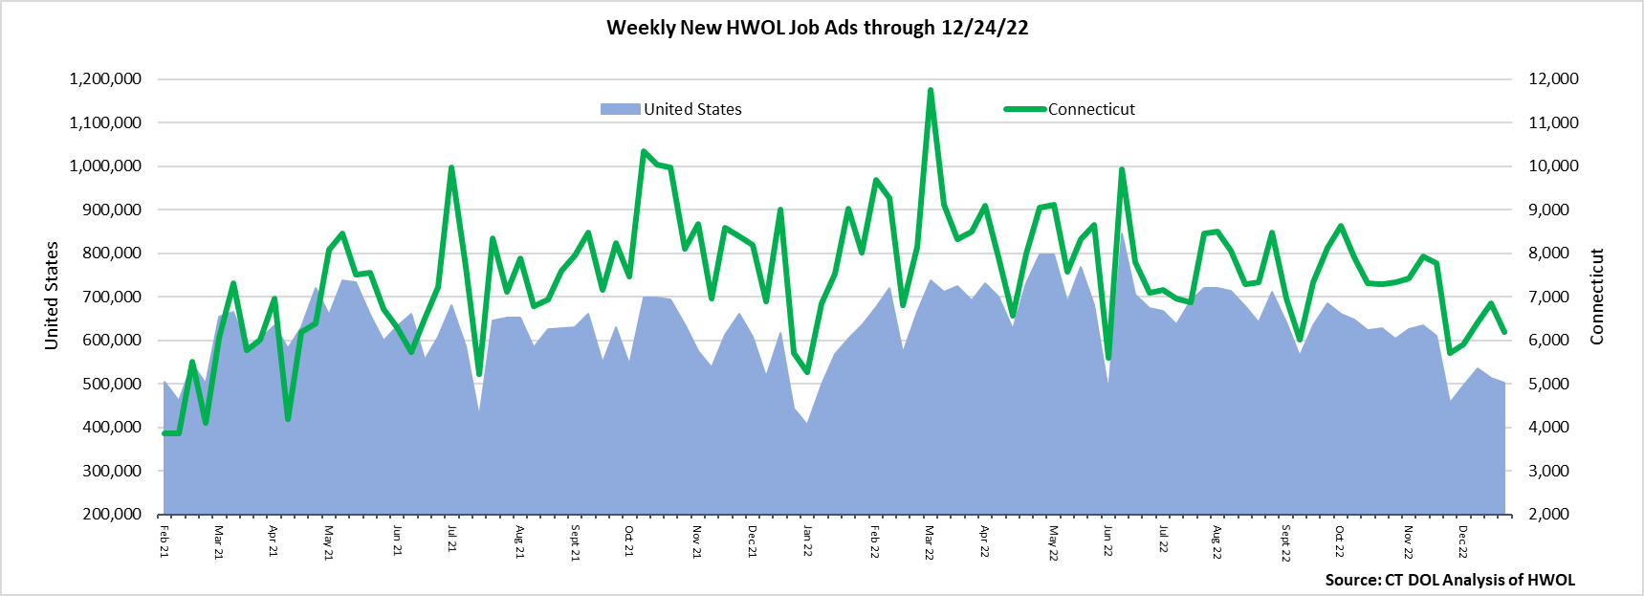  
**Industries** with the most new postings include Health Care & Social Assistance, Finance & Insurance, and Retail Trade.

**Occupations** with the most new postings include Registered Nurses, Retail Salespersons, and Supervisors of Retail Sales Workers.

**Employers** with the most new postings include Hartford Healthcare, Community Health Center Inc., and Trinity Heath.

**The three industries with the most new job postings were:**

* **Health Care & Social Assistance** (1,625 new postings, -29% over the week)
* **Finance and Insurance** (597 new postings, +5% over the week)
* **Retail Trade** (562 new postings, -10% over the week)

   
 During the week ending December 24th, 2022, the 10% new ad total decrease is the net result of decreases in ten industries and increases in ten industries. The decreasing industries were down a combined 969 new ads, and Health Care & Social Assitance accounted for 679 of that combined decline. This drop during the most recent week corresponds with similar gains the week before. Health Care was up 639 new ads during the week ending December 17th. The other declining industries had over the week drops of less than 75 new ads. The ten increasing industries had slight gains that were mostly less below 100 new ads.   
  
 For more information on total job ads by industry for Connecticut and its labor market areas, see the monthly report available here: <https://www1.ctdol.state.ct.us/lmi/hwol.asp>

**New Job Postings by Occupation** 

**The occupations with the most new postings were:**

* Registered Nurses (431 new postings, -40% over the week)
* Retail Salespersons (164 new postings, +4% over the week)
* Supervisors of Retail Sales Workers (140 new postings, -10% over the week)

**Employers with the Most New Job Postings** Employers with the most new job postings during the week were mostly in Health Care & Social Assistance, Retail Trade, and Finance & Insurance. The 25 employers shown above account for 21 percent of all new ads. 15 of 25 employers in the top 25 increased over the week and 10 decreased. Seven employers were in Healthcare & Social Assistance and four of those seven had the largest over-the-week declines within the top 25. Hartford Healthcare was down the most (-208 new ads) over the week and was previously up 266 new ads during the week ending December 17th. Among the top 25 employers, the largest increase occurred at Trinity Health (+79 new ads).  
  
**What is HWOL?**The **Conference Board Help Wanted Online**® Data Series (HWOL) measures the number of new, first-time Online job postings and jobs reposted from the previous month for over 16,000 Internet job boards, corporate boards, and smaller job sites that serve niche markets and smaller geographic areas. To view more HWOL data, go to: <https://www1.ctdol.state.ct.us/lmi/hwol.asp>